

Lab #10
Artificial Intellegince
SUBMITTED BY:
UBAID AHMAD
ROLL NO:
2410-0011
SUBMITTED TO:
Ma’am Warda Asad
DATE:
03/05/2026

Lab TASKS:
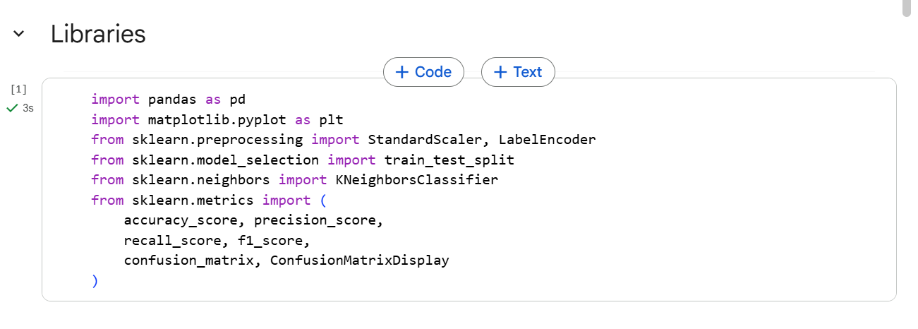
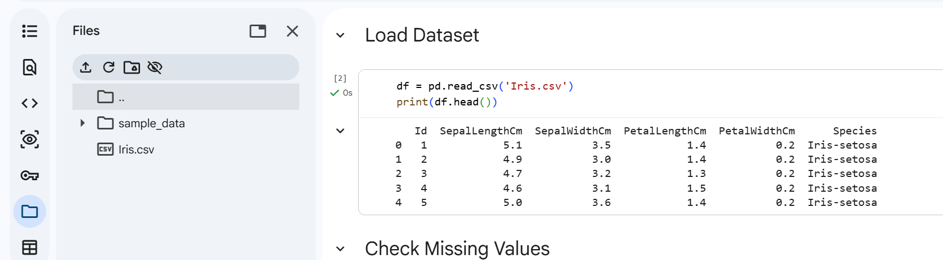
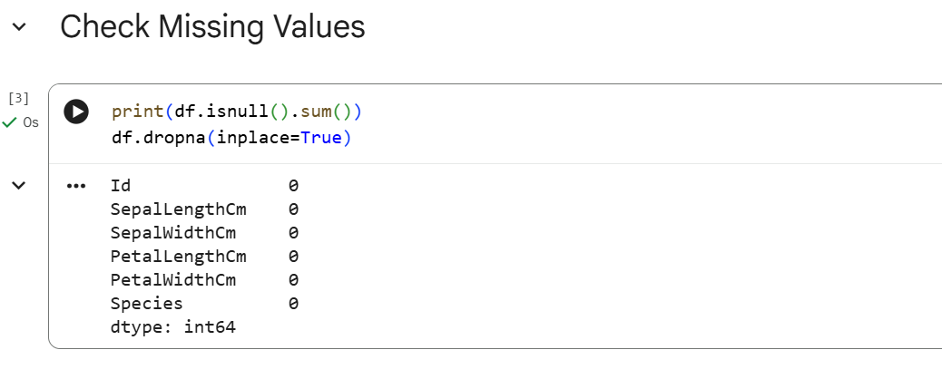

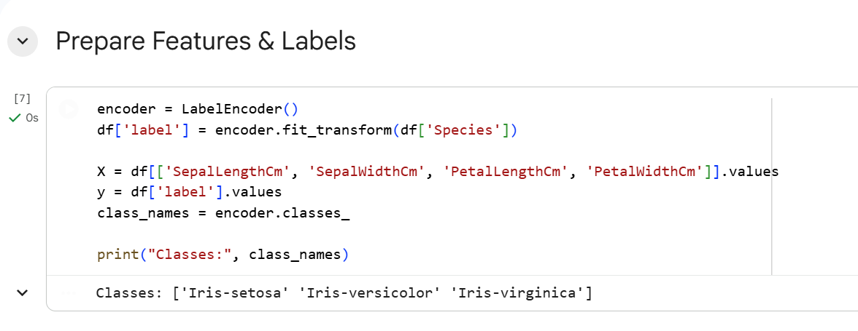
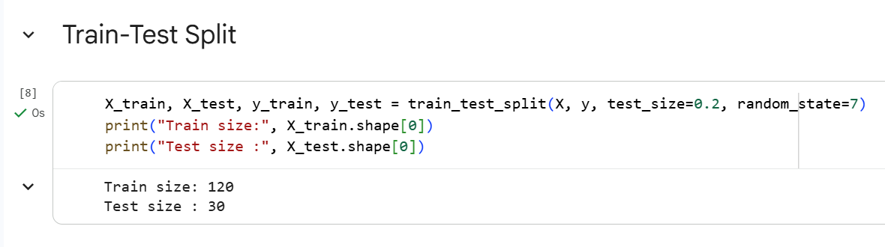
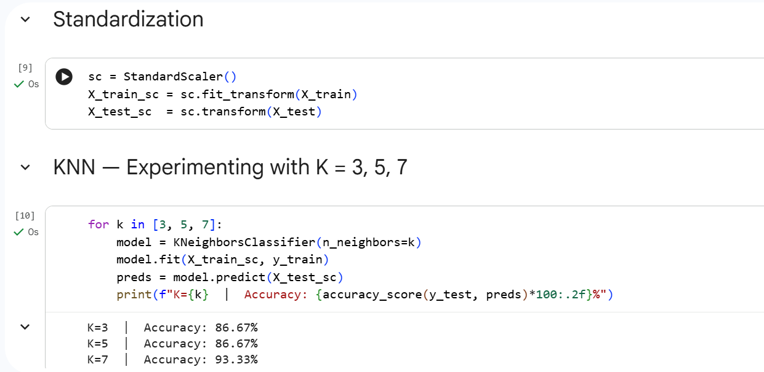

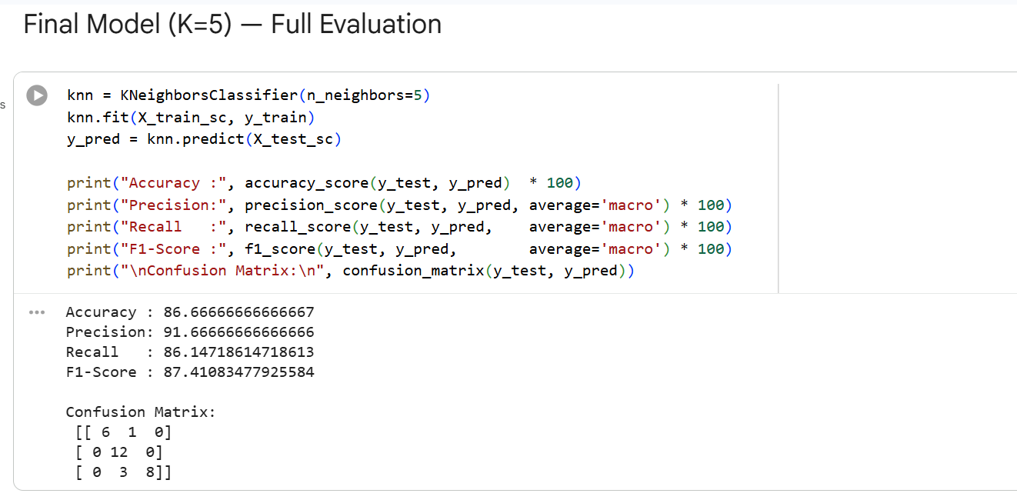
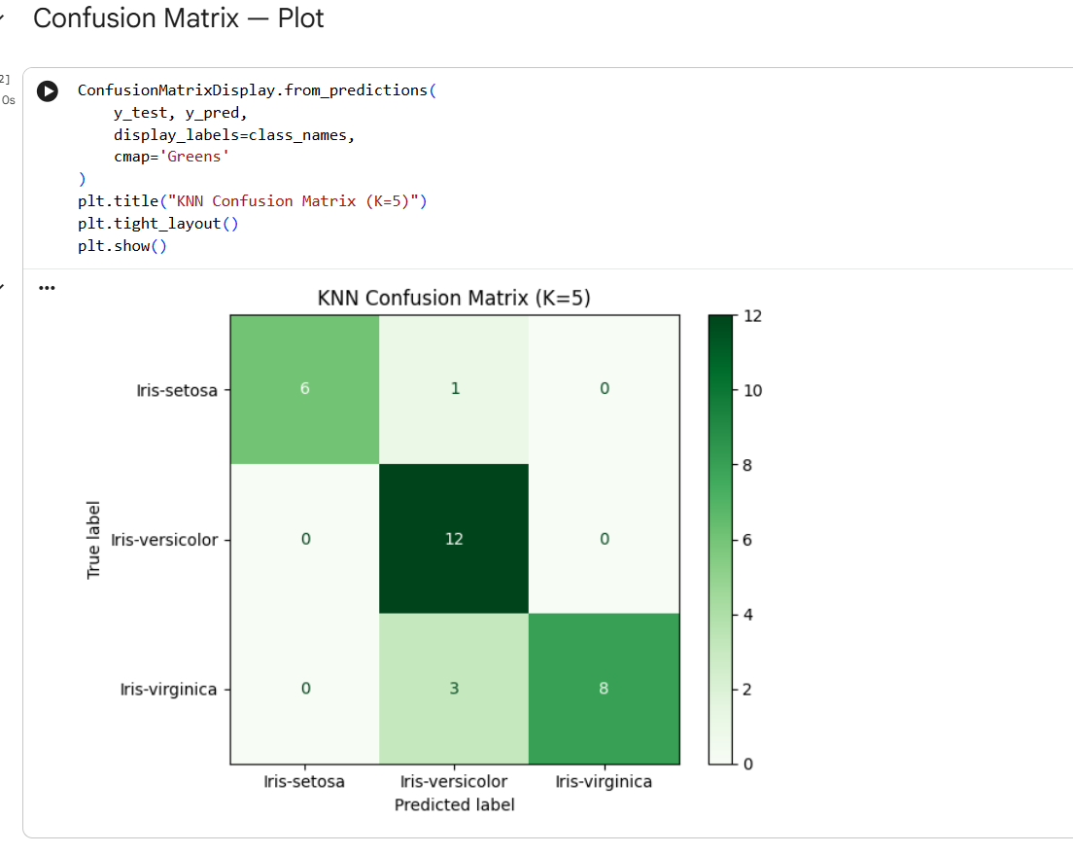

END,,,

